Intrinsic and extrinsic tooth discoloration.
The effectiveness of KTP laser-assisted tooth bleaching system, its’ advantages and reports comparing different bleaching systems.

Submitted by
Sotiria Delli DMD

New York University College of Dentistry
Center for Continuing Education

Month : September | Year: 2007

Table of Contents

2 Introduction
3 Summary
5 Discussion
18 Conclusions
19 Bibliography
INTRODUCTION
The attractiveness of a smile is an important component of oral health. The color and arrangement of the teeth and the relationship to the soft tissues and bones of the face, give the overall aesthetic value of the human face. Of the components, the shade of the teeth is the easiest to alter and thus to gain a cosmetic improvement for the dental patient. Having said this; it must be remembered that the health of the gingival tissues can greatly affect the appearance of the smile. Thus, periodontal care is an important part of cosmetic dentistry and should be undertaken before any attempt of tooth-discoloration.
The basic strategy is to first identify the aetiology of the discoloration and to apply the selected treatments using the philosophy as much as required, but as little as necessary or else “minimal invasive dentistry”.

SUMMARY
When confronted clinically with the problem of tooth discoloration, the basic strategy is to first identify the aetiology of the discoloration, and then to apply the selected treatment. Today, increasing efforts are being made to offer the patient successful, pain-free bleaching, of both extrinsic and intrinsic stains. Concern has been expressed about efficacy limitations, such as the time for color rebound, the intensity of the stain that can be removed, and safety limitations including tooth sensitivity, enamel microhardness, and pulp temperature.
With external staining a superficial layer forms on the surface of the tooth, through the action of dietary or lifestyle factors, such as tobacco, tea or coffee, tannin-containing drinks or food, or because of chromogenic bacteria, or components in saliva.
On the other hand, with internal discoloration, intrinsic stains such as pigments of various types have become incorporated into the enamel or dentine, either during its formation, or after eruption. As many as fifty different conditions either locally, systematically or because of a genetic aetiology, have been causally linked to developmental disturbances in tooth formation. The most widely known cause of staining is tetracycline. Fluorosis is another reason; white spots can be caused by fluorosis or can be generated by developmental disorders. Other reasons are: the advanced age, or mal habits, amalgam restorations, endodontic pathology and endodontic treatment. Blood products can, also, cause both pre- and post- eruptive discoloration.
Nowdays, in our practice there is a plethora of different discoloration methods. Bleaching is one of them and again there is home-bleaching and in-office bleaching. The in-office bleaching can be light activated, or not, thermal activated e.t.c.
To be able for the dendist to provide to his patient the best discoloration treatment, depending on the circumstances, he or she must take under consideration comparative studies, concerning different bleaching methods, and be able to keep up with new technologies or at least be informed and familiar about most of the options available.
There are researches that prove that colour and temperature changes were significantly affected by an interaction of the bleach and light variables but it was always an issue the pulp rising temperature. The application of light significantly improved the whitening efficacy of some bleach materials, but it caused significant temperature increases in the outer and inner tooth surfaces. The IR and CO₂ laser lights caused the highest tooth temperature increases. Another research treaded anterior stained teeth with peroxide and light, peroxide alone and light alone, and proved that peroxide and light treatment significantly lightened the colour of teeth to a greater extent than did peroxide or light alone, with a low and transient incidence of tooth sensitivity. This research, also, proved once more, that light itself appeared to have a bleaching effect.
Green laser light 532 nm KTP has the unique property of optimal absorption by chromophores which cause tooth discoloration. In cases of severe tetracycline staining, this technique also offers substantial improvement. The interaction of this kind of laser energy with the tetracycline-hydrochloride complex results in the breakdown to a red quinone (AODTC) which in turn can be further broken down by light, but can also be effectively oxidized by H₂O_{2.}
Sensitivity is rare, there is no dehydration of the enamel, and compared with Diode laser and LED the enamel microhardness is not significantly affected. Also, KTP-laser is able to produce significantly brighter teeth, and to induce a safer pulpal temperature. Therefore, KTP is potentially a valid and safe tool for in office discoloration with faster, safer, and more predictable results.

DISCUSSION
1. EXTRINSIC DISCOLORATION and its treatment
For extrinsic discoloration, the tooth surface can be treated e.g. removal of stains and surface deposits by professional prophylaxis or soda. Enamel micro-abrasion is also a great utility, since by smoothing the labial enamel surface, this treatment also increases light reflectance from the surface.

2. INTRINSIC DISCOLORATION and its treatment
2.1 AETIOLOGY
On the other hand, with internal discoloration, intrinsic stains such as pigments of various types have become incorporated into the enamel or dentine, either during its formation, or after eruption.
Internal discoloration is a diagnostic challenge. Developmental defects can be defined as disturbances in hard tissue matrices and in their mineralization arising during odontogenesis. As many as fifty different conditions either locally or systematically or a genetic aetiology, have been causally linked to developmental disturbances in tooth formation ⁶ Altered tooth structure may not only stain, but may also be more prone to increased penetration of chromogens from the diet.
Development of defects in enamel may be caused by a rang of factors including; birth trauma, premature birth and low birth weight, neonatal hyper-bilirubinaemia (jaundice), febrile bacterial infections such as measles and chickenpox, anti-neoplastic drugs used to treat malignancies in young children and major nutritional deficiencies during the early years of life (particularly vitamins A, C and D).
In icterus gravis neonatorum, high levels of circulating bilirubin in the infant, cause clinical jaundice. Bilirubins from the peripheral circulation can become incorporated into tooth structure which is still forming, causing a yellow-green discoloration and hypoplasia of the primary teeth. The permanent dentition however, is not affected as the state of hyperbilirubinaemia is short lived.
Enamel malformation and hypoplasia can be caused by poor maternal nutrition, particularly a high alcohol intake and deficiencies in vitamins and major nutrients during pregnancy. Other medical problems affecting the pregnant woman that can cause enamel hypoplasia in the infant include poorly controlled diabetes mellitus, toxaemia of pregnancy, hypocalcaemia, hypothyroidism, hypoparathyroidism, gastrointestinal mal absorption, liver malfunction and chronic renal failure.
Several uncommon medical and inherited conditions have also been associated with alterations in tooth structure, including internal discolorations. Such medical condition includes congenital erythropoietic porphyria, phenylketonuria, trichodento-osseous syndrome and incontinentia pigmenti, Ehlers-Danlos syndrome, and cleidocranial dysplasia. In congenital erythropoietic porphyria, there is increased formation and excretion of porphyrins, which can result in purple-red or red-brown discoloration of the dentine in both the primary and permanent dentitions. Under ultraviolet light the porphyrins in the affected dentine emit a red fluorescence.
In alkaptonuria and phenylketonuria affected individuals are unable to oxidize homogentisic acid, a metabolite in the oxidation pathway of the amino acids tyrosine and phenylalanine. With the passage of time, abnormal pigmentation may occur in cartilage, connective tissues and teeth. Within the teeth the homogentisic acid oxidizes to a colored quinone compound within the alkaline environment of mineralization, resulting in a dark brown discoloration. The same event can occur in patients with phenylketonuria.
Inherited disorders affecting hard tissues are relatively uncommon. In amelogenesis imperfecta, the tooth color ranges from an opaque white to yellow and tend to darken with age. Because of increased porosity, newly erupted teeth may become stained from dietary and other chomogens. In dentinogenesis imperfecta, the teeth are opalescent and discolored with a color ranging from bluish-grey to brown to yellow.
Disturbances which affect teeth suggest a local etiology, such as damage to the tooth germ of a permanent incisor from infection or trauma involving the deciduous precursor which is located immediately adjacent. Conditions that involve many teeth suggest a systemic disturbance or a genetic aetiology. Thus, trauma to the primary maxillary incisors can result in an area of chronia periapical infection that will be juxtaposed by the labial aspect of the developing permanent central incisor. Cariously exposed deciduous molar can exert similar effects on the premolars. In both situations damage to the ameloblasts of the permanent tooth germ alters the maturation of enamel at the site of injury. This explains why these defects are usually very well defined.
Other intrinsic discolorations are caused when blood products can cause both pre- and post eruptive discolorations in teeth. A common post eruptive cause of such discoloration is a trauma to an incisor tooth prior to eruption. The same thing occurs in patients with sickle cell anaemia and thalassaemia. In the latter two conditions, the discoloration is more severe and does not improve with time.
Endodontic pathology and endodontic treatment cause also post eruptive intrinsic discoloration. Internal hemorrhage within the pulp chamber can result in an appearance much like a bruise, while necrosis of the pulp, with the associated degradation of the pulp by ischaemia and bacterial infection, typically results in greyishbrowm discoloration. Following trauma to a tooth that retains vitality but undergoes sclerosis or dystrophic calcification, a marked yellowing can occur. Moreover, internal resorption can lead to a pink discoloration as the resorbing tissue destroys the normal dentine and enamel which overlay the dental pulp.
Corrosion products from amalgam restorations can cause also intrinsic discoloration as they can react with sulphur to form silver and mercuric sulphides, with grey and black colorations as a result.
Also, with advanced age or mal habits, the enamel becomes thinner because of attrition allowing the yellow color of the underlying more sclerotic dentin to be seen more clearly. As secondary dentin is deposited within the dentinal tubules this accentuates the normal yellow coloration of the dentin and causes optical isotropy that is less bending and distortion of light as it moves across the dentine.
The most widely known cause of intrinsic staining is tetracycline. Tetracycline molecules incorporate hydroxyapatite crystals during the mineralization stage that is part of tooth development. They can accumulate in enamel but form primarily in dentition; hypoplasia of the enamel is even possible. Discoloration can be yellow, yellow-brown, brown, grey or blue, possibly with stripes being formed and it is often bilateral. The degree of seriousness depend on several factors, for instance age, they must be avoided between 3months to 7years of age, the length of administration, the dosage, the type of tetracycline.
Fluorosis is due to an excess of fluoride during formation of the enamel matrix and calcification and brings about hypoplasia of the enamel and white spots. The darker coloring is due to extrinsic factors following dental eruption and features roughness; often it is even possible to observe quite pronounced pitting in the enamel. The manifestations of dental fluorosis depend upon the peak concentrations achieved in the blood following exposure to fluoride, the duration of exposure, and the age of the subject. The critical period is during the maturation period of tooth enamel, which for the cosmetically important maxillary anterior teeth is the second and third year of life.
White spots can also be caused by trauma. They can also be generated by development disorders (congenital mal formations, fever or other diseases), but all cases involve demineralization. This mottling can also occur after eruption with the most common variety due to plaque accumulation around brackets and linked to poor oral hygiene. In such cases enamel micro abrasion or etching is used depending on the case combined with regeneration of the sub surface using recaldent CPR – ACP⁴ to have a better esthetic result.^{8,4}
Staining due to amelogenesis imperfecta, dentinogenesis imperfecta and other etiologies which interfere with the formation of normal matrix or enamel and dentine calcification are not treatable using any bleaching technique. Moreover, any bleaching treatment is always contraindicated because the structural integrity of the teeth is severely compromised.

2.2 TREATMENT
However, for internal discoloration, options include:

- Chemical bleaching with peroxide compounds, either passively or assisted by heating.
- Photochemical bleaching (e.g. green laser light for tetracycline staining) or light-activated (e.g. halogen curing light or ΙR light, led, plasma etc)
- Masking the discoloration with an opaque composite resin veneer, a porcelain laminate veneer, or a full crown.

3. COMPARATIVE STUDIES on bleaching systems
It has long been known that those areas of discoloured teeth exposed to sunlight are whiter than those which are not². There is a survey of studies, in which heat –activated, external bleaching procedures were compared. ⁷ The results differ from study to study. There are researches that prove that colour and temperature changes were significantly affected by an interaction of the bleach and light variables but it was always an issue the pulp rising temperature. One of them tested a placebo gel, a 35%hydrogen peroxide or a10%carbamide peroxide bleach¹ that where irradiated with no light; a halogen light an infrared, IR light an argo laser; or a carbon dioxide, or CO₂ laser. The application of lights significantly improved the whitening efficacy of some bleach materials, but it caused significant temperature increases in the outer and inner tooth surfaces. The IR and CO₂ laser lights caused the highest tooth temperature increases.

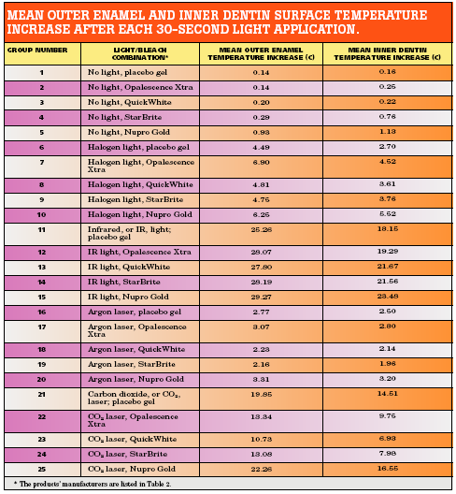

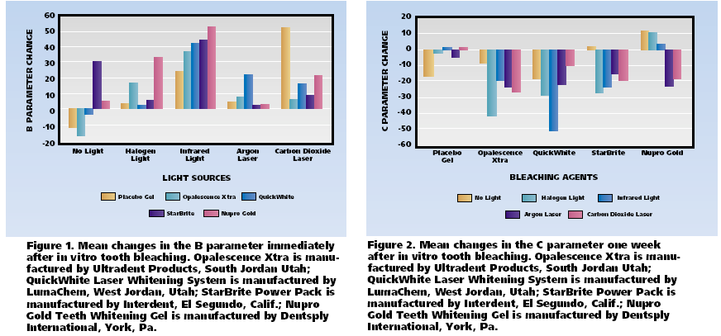
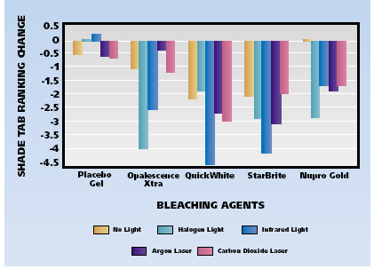 | 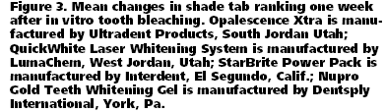

Another research treaded anterior stained teeth with peroxide and light, peroxide alone and light alone, and proved that peroxide and light treatment significantly lightened the colour of teeth to a greater extent than did peroxide or light alone, with a low and transient incidence of tooth sensitivity³. This research also proved once more that light itself appeared to have a bleaching effect.

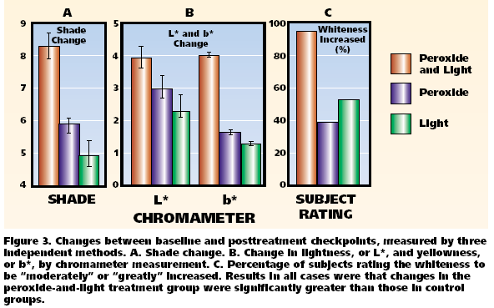
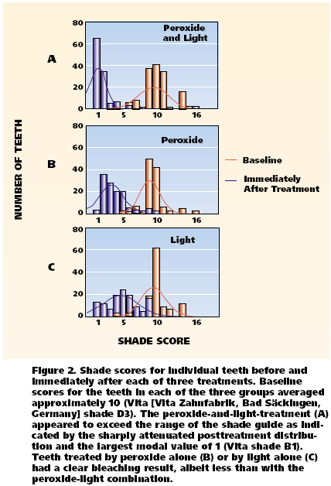
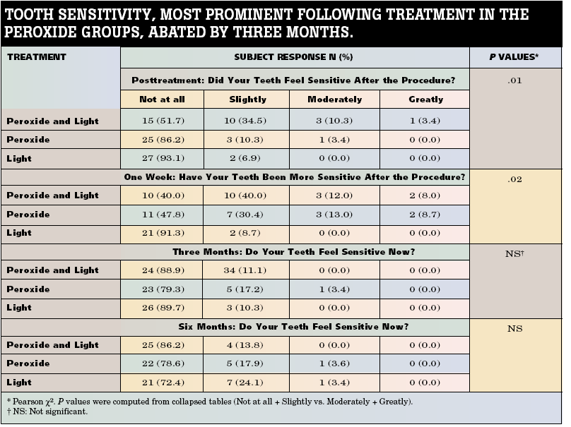

4. KTP LASER ASSISTED BLEACHING and its advantages

Bleaching is the splitting of large molecules into smaller ones. When large molecules are incorporated into dental tissue they absorb light instead of reflecting it, thus causing dark teeth or staining. As a result of bleaching the smaller molecules are no longer in a light-absorbent state; the greater the level of reflection is the whiter teeth are.
The use of laser energy provides substantial benefits in bleaching treatment. KTP laserbleaching system overcomes some of the problems that other lasers provoke like high pulp temperature rising.
Generally yellow discolorations are the easiest to bleach. Brown discolorations are more difficult to bleach, while grey discolorations and tetracycline staining are the hardest to bleach. .
The chelate formed between tetracycline and hydroxyapatite or calcium orthophosphate is the red quinone product (AODTC). This colored product is relatively resistant to oxidation from peroxide, but can be broken down (photo-oxidised) by green light , in a particular narrow spectral range of visible green light(512 to540 nm).¹⁰ AODTC has a maximum absorption at 530 nm in the visible green spectrum and can be broken down (photo –oxidised) by light at this wavelength. Lin and others¹⁰ showed that tetracycline staining could be removed from teeth that were intensely stained with tetracycline by using only light, provided it was in the specific wavelength of absorption of the AODTC complex, ie, the 512 to 534 nm band. Patients with intense tetracycline staining typically show a banded pattern, with less marked staining of the incisal edges of the maxillary incisor teeth. This effect occurs because the incisal edges of these anterior teeth may lighten with time, according to the extent of their exposure to sunlight. The posterior teeth do not change color as they do not get significant exposure to sunlight. Under these conditions, the molecule breaks down to a simpler quinone, which can be then oxidized using conventional bleaching materials such as hydrogen peroxide.
Laser light of the appropriate wavelengths can be generated using argon on KTP Laser (514.5 and 532 nm, respectively).
The above theoretical background is incorporated into the KTP laser bleaching technique; the use of laser light in the green range together with hydrogen peroxide dissolved in a chemical agent to induce a photochemical reaction and produce highly reactive perhydroxyl radicals in a basic solution.
The KTP laser-bleaching system employs photochemical and not photothermal reactions, at an alkaline pH, to both break down tetracycline stains and to produce reactive oxygen molecules. The gel has a high pH ~9,5. Under these alkaline conditions, the perhydroxyl radical is produced from hydrogen peroxide. This radical is more reactive than superoxide and other radical. In addition, under alkaline conditions, etching of the tooth surface does not occur nor dehydration.
Therefore, the shade changes that occur are not simply the effect of the teeth being etched, which in itself could cause some rebound within a short time period. The treated teeth should have normal luster and the pattern of light reflection from them should be unchanged. In addition, tooth sensitivity is less than other systems and doesn’t last since the teeth, as we mentioned, are not etched or dehydrated during the treatment process.
However, a minimum period of two week waiting is required before replacement of the composite fillings or any other prosthetic adjustments because the residual oxygen has to dissipate completely out of the dental tissue otherwise it will inhibit the polymerization reaction of the composites. In addition, exposure of enamel to 35% hydrogen peroxide for 5 to 30 minutes has been shown to cause a significant reduction in the adhesive bond strength of composite resin to enamel.
The KTP bleaching system has also been shown by electron probe microanalysis to give rapid and deep penetration of oxygen molecules into intact tooth structure. In contrast, with home bleaching treatments, the penetration is superficial. Also (OH) ¯ bonds that have been created are considered to be more resisted to time. At the end of the procedure fluoride and laser energy is used as a prevention of future decay. This laser fluoride treatment is able to reduce the acid solubility of the enamel. This helps to protect the teeth from corrosion, also, particularly from acidic drinks.
Since the motto that stands nowadays is “minimal invasive dentistry”, we have to take into consideration comparative studies of bleaching systems. It is for a fact known that bleaching techniques achieved significant advances with the use of coherent or incoherent radiation sources to activate the bleaching agents but there where some issues needed to be taken under consideration e.g. the pulp temperature and the enamel micro hardness.

5. A COMPARATIVE STUDY concerning KTP laser bleaching system ⁹
A recent in vitro study examines the whitening efficacy of a light-emitting diode (LED), a diode laser and a KTP laser irradiation in dental bleaching by analyzing the change in color achieved from the treatment, the temperature increase induced in the pulp cavity, as well as enamel micro hardness measurement after treatment. The results showed:
- A mean total color difference value (ΔΕ) greater than 5.0 was obtained in each group. KTP laser-indused bleaching gave a significantly higher ΔL∞ (8, 35) after treatment (p<0,001).
- Neither LED nor the two lasers produced significant differences in the enamel micro hardness after treatment (p>0, 01).
- Mean maximal pulpal temperature rise was 2, 95°C for LED 3, 76°C for KTP laser and 7, 72°C for diode laser respectively.
This means that diode laser caused significantly higher intrapulpal temperature rise, which was a disadvantage, whereas KTP laser and LED showed pulp-reserving results under the condition tested. The results suggest that KTP laser is effective at providing brighter teeth. Results are obtained more predictable and faster and safer for the teeth, not to mention the advantage of KTP-laser energy in the treatment of difficult discoloration e.g. due to tetracycline.

COLOR CHANGES IMMEDIATELY AFTER BLEACHING

Givups | Δ.L* | Δa* | Δb* | ΔE*
1 | 8.35 (2.72)° | 0.87 (0.34) | —3.10(1.46) | 8.79 (3.05)
2 | 4.96 (1.98) | 1.37 (0.56) | —2.38(1.12) | 5.74 (2.04)
3 | 4.73 (1.87) | 1.74 (0.69) | —3.61 (1.29) | 6.41 (2.47)
4 | 4.25 (1.66) | 1.59 (0.72) | —2.63 (1.03) | 5.22(2.20)
Significant difference (p <0.01).
Values show the mean and standard deviation. ΔL5 = L* (post) _L* (0). Δa* = a* (post) — a* (0) , Δb* = b* (post) — b* (0), where post is the value post-treatment and 0 is the value at baseline. Total color difference values (ΔE*ab) between baseline and subsequent measurements were calculated according to the following formula: ΔE*ab = [(ΔL)²+ (Δa)²+ Δb]²]^{1/2}
INTRAPULPAL MAXIMAL TEMPERATURE RISE WITH VARIOUS LIGHT SOURCES
 |  | Maximal temperature
Groups | Light sources | rises (°C)
a | KTPlaser | 3.76(1.17)
b | Diode laser | 7.72 (2.61)a
c | LED | 2.95 (1.25)
a Significant difference (p <0.01).
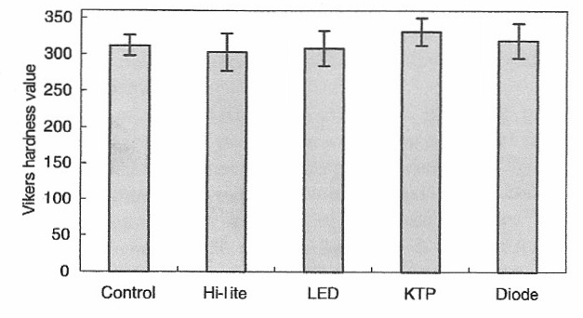
Mean enamel Vickers microhardness values after different treatments. Statistical analysis revealed no significant differences among the five groups (p> 0.01).
6. CONCLUSION
Green laser light 532 nm KTP has the unique property of optimal absorption by chromophores which cause tooth discoloration. In cases of severe tetracycline staining, this technique also offers substantial improvement. The interaction of this kind of laser energy with the tetracycline-hydrochloride complex results in the breakdown to a red quinone (AODTC) which in turn can be further broken down by light, but can also be effectively oxidized by H₂O_{2.}
Sensitivity is rare, there is no dehydration of the enamel, and the enamel microhardness is not significantly affected. Also, KTP-laser is able to produce significantly brighter teeth. Therefore, KTP is potentially a valid and safe tool for in office discoloration with faster, safer and more predictable results.
BIBLIOGRAPHY
- Effect of light energy on peroxide tooth bleaching by Karen LUC, D.D.S.; Laura Tam, D.D.S., M.SC.; Manfred Hubert, Ph. D (JaDa vol. 135 February 2004).
- Laser-assisted bleaching: Smalt bleach ^{T.M.} by Peter Verheyen (J. Oral Laser Applications 2001: 1: 207-215)
- Light augments tooth whitening with peroxide by Mary Tavares, D.M.D., M.P.H.; Jacun STULTZ R.D.H.;Margared Newmann, R.D.H.; Valerie Smith; Ralphkent, Sc.D.; Elizabeth Caprino, B.A.; Jo Max GOODSON, D.D.S., Ph.D (JaDa, vol. 134, February 2003).
- White spots by proj. Laurie Walsh.
- Esthetic Dentistry with Smartbleach: An overview of clinical cases by Koen Overloop, Romain Blum, Peter Verheyen (J. Oral Laser Applications 2003; 2: 129-134).
- Tooth Discoloration and its Treatment using KTP Laser-assisted Tooth whitening by Laurence J Walsh, Jackson Y. Lin, and Peter Verheyen (J. Oral Laser Applications 2004; 4: 7-21).
- External bleaching therapy with activation by heat, light or laser A systematic review by Wolfgang Buchalla, Thomas A Hin (dental materials 23 – 2007).
- The use of microbrassion for cleaning discoloring enamel by Christopler D Lunch, Robert J. MCCONNELL (Dentorama, vol. 10.2005).
- Effects of KTD Laser Irradiation, Dide Laser and LED on Tooth bleaching: A comparative study (photomedicine and Laser Surgery, vol. 25 No 2 2007)
- Lin LC, Pitts DL Burgess LW. An investigation into the feasibility of photo bleaching tetracycline-stained teeth.(J. Endodont 1988; 14:293-299)

